Grouping Cities to Compare Living Conditions
Ziyao Zeng | Adapted from STAT 437 Assignment 7
1. Research motivation and dataset
People considering a move may care about the overall living environment, which depends on more than wealth alone. I use five representative well-being indicators to group cities and compare their living conditions. The goal is to help people identify types of cities that may suit their priorities.
I use the cleaned, 155-city MoveHub dataset supplied in STAT 437, based on the MoveHub City Rankings dataset on Kaggle. The five indicators are Purchase Power, Health Care, Pollution, Quality of Life, and Crime Rating. City, Country, and Region identify the cities and are kept out of the distance calculations.
Source listed in course materials: MoveHub City Rankings (Kaggle).
2. Data processing and scaling
The variables have different variances and spreads, which could give some variables too much weight in the clustering. I use StandardScaler to put the five numerical variables on a similar scale. The supplied dataset is already cleaned.
df = pd.read_csv("movehub_data_cleaned2.csv") # load city data
scaler = StandardScaler()
num_cols = ["Purchase Power", "Health Care", "Pollution", "Quality of Life", "Crime Rating"]
# scale numerical indicators
df[num_cols] = scaler.fit_transform(df[num_cols])
3. Compare clustering methods
I compare single, average, complete, and Ward linkage for k=2 through 11. These methods differ in how they measure the distance between groups, so they may group the same cities differently. I use silhouette scores to compare their results: higher scores suggest closer similarity within groups and better separation between groups.
for link in ['single', 'average', 'complete', 'ward']: # compare linkage methods
avg_ss = []
for k in range(2, 12):
hac = AgglomerativeClustering(n_clusters=k, linkage=link)
Y_pred = hac.fit_predict(df[num_cols])
avg_ss.append(silhouette_score(df[num_cols], Y_pred)) # silhouette score
print(link, "best k =", avg_ss.index(max(avg_ss)) + 2, "score =", round(max(avg_ss), 3))

Output: best result for each linkage
single best k = 2 score = 0.217
average best k = 2 score = 0.356
complete best k = 2 score = 0.381
ward best k = 2 score = 0.365

Complete linkage with k=2 gives the highest silhouette score (0.381), so I use it as a starting point. However, my goal is to describe useful differences in living conditions, so I also check whether this division combines cities that would be helpful to compare separately. I use t-SNE to look at the two-group and three-group results side by side.
Compare k=2 and k=3 visually
tsne = TSNE(n_components=2, perplexity=20, random_state=88) # t-SNE model
data_tsne = tsne.fit_transform(df[num_cols])
df_tsne = pd.DataFrame(data_tsne, columns=["x_projected", "y_projected"], index=df.index)
df_combo = pd.concat([df, df_tsne], axis=1) # combine city data and coordinates
for k in [2, 3]:
hac = AgglomerativeClustering(n_clusters=k, linkage='complete')
df_combo['predicted_cluster'] = hac.fit_predict(df[num_cols]) # cluster labels
sns.scatterplot(x='x_projected', y='y_projected', hue='predicted_cluster',
palette=sns.color_palette("husl", k), data=df_combo)
plt.show() # compare clusterings

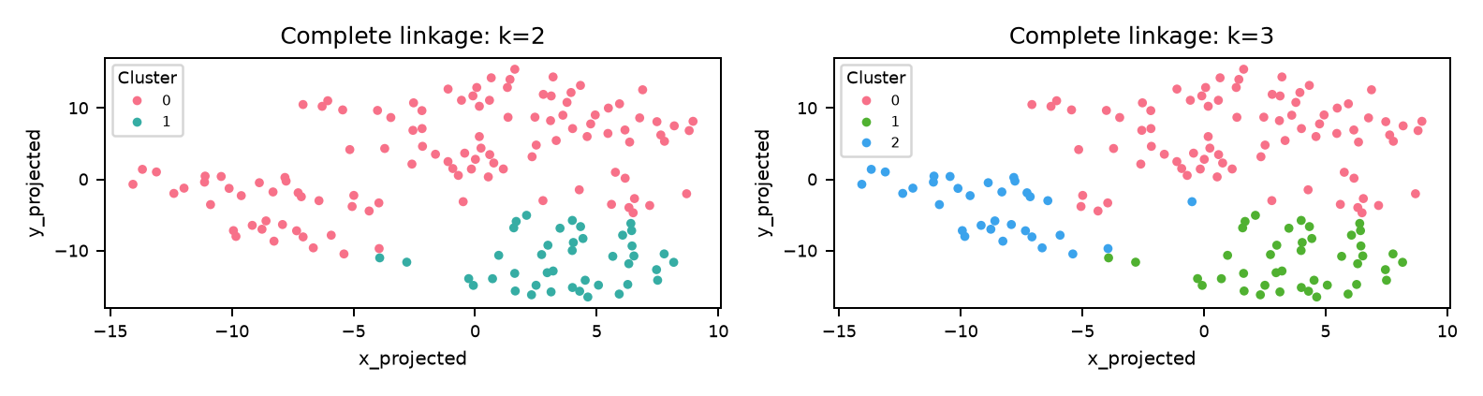
The plots seem to show about three groups. With k=3, Cluster 0 from the k=2 result splits into Cluster 0 and Cluster 2, while Cluster 1 stays together. This separates the upper and lower-left groups more clearly. Although the silhouette score falls to 0.302, I choose k=3 because it keeps this extra distinction rather than combining both areas into one cluster.
4. What distinguishes the three city groups?
hac = AgglomerativeClustering(n_clusters=3, linkage='complete') # final model
df['predicted_cluster'] = hac.fit_predict(df[num_cols])
# compare indicators across clusters
def compare_clusters(df, num_cols):
for col in num_cols:
sns.boxplot(x='predicted_cluster', y=col, data=df)
plt.show()
compare_clusters(df, num_cols) # draw boxplots

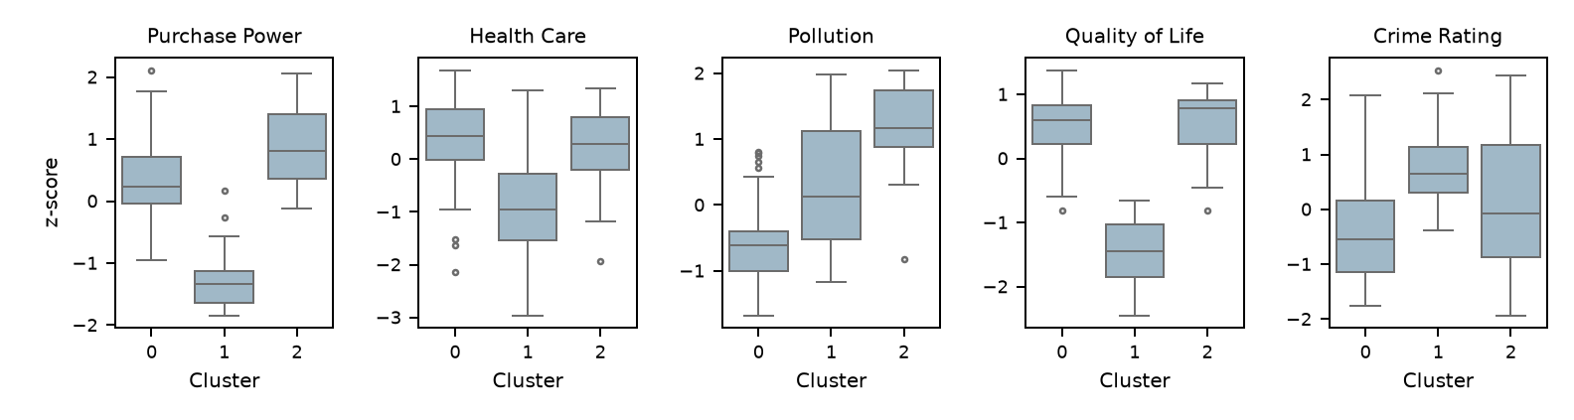
Cluster means in standardized units
cluster_means = df.groupby('predicted_cluster')[num_cols].mean() # group means
cluster_means = cluster_means.round(2)
print(cluster_means.to_string())

Cluster | Purchase Power | Health Care | Pollution | Quality of Life | Crime Rating
0 | 0.32 | 0.39 | -0.62 | 0.53 | -0.47
1 | -1.29 | -0.92 | 0.29 | -1.43 | 0.79
2 | 0.89 | 0.22 | 1.19 | 0.54 | 0.16

The boxplots show how each indicator varies within and between the clusters. Cluster 0 tends to have better health care and quality of life, together with lower pollution and crime ratings. Cluster 1 generally has lower purchasing power, health care, and quality of life, along with higher crime ratings.
Cluster 2 has the highest average purchasing power and pollution, while its average quality-of-life score is close to Cluster 0. This is the main reason the extra group is useful: similar overall quality of life can come with different living conditions. The boxplots use standardized values, so zero represents the dataset average for each indicator.
The cities closest to their cluster mean profiles are Sydney in Cluster 0, Lima in Cluster 1, and Orlando in Cluster 2. I use distance across all five scaled indicators to find these representative cities.
5. Conclusion
The three groups show why wealth alone is not enough to compare places to live. Someone who values lower pollution and crime might start with Cluster 0, while someone who puts more weight on purchasing power might compare cities in Cluster 2. These profiles give people a clearer way to narrow down cities that match their preferences.

